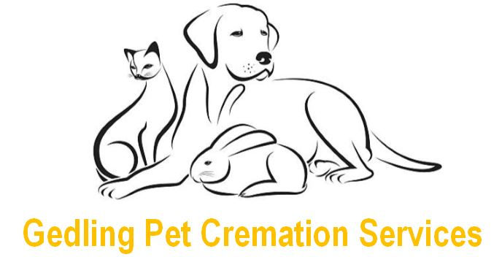

Pets Name: …………………………………………………………………………………..
Sex (please circle one): Male Female
Type of Pet (please circle one): Cat Dog Rabbit Guinea Pig/Hamster
If other please specify: ……………………………………………………………………...
Owner’s Name(s): ……………………………………………………………………………
Owner’s Address: …………………………………………………………….......................
………………………………………………………………………………………………….
………………………………………………………………………………………………….
Postcode: ……………………………………………………………………………………..
Telephone: ……………………………………………………………………………………
Email: ………………………………………………………………………………………….
Veterinary Practice: …………………………………………………………………………..
Telephone No. of Vet: ………………………………………………………………………...
To whom it may concern,
In the event of the death or euthanasia of the above named pet, I instruct you to contact Gedling Pet Cremation Services on my behalf to arrange for their collection and individual cremation.
I have already made / will make the remainder of the arrangements including payment directly with Gedling Pet Cremation Services.
Signed: ……………………………………………...
Date: ……………………..……….
Contact: 0115 901 3713
Email: petcremations@gedling.gov.uk
Website: www.gedlingpetcremations.co.uk

For information on how Gedling Pet Cremation Services uses your personal data visit www.gedlingpetcremations.co.uk/privacy-policy/

Cremation Consent Form

Dear Pet Owner,

Please complete the attached Cremation Consent Form which will act as confirmation of your wish to have your pet looked after by Gedling Pet Cremation Services. Please feel free to contact us if you have any questions or would like any help or further information about our service.
Once you have completed and signed the attached letter, please print and give to your veterinary practice.
Please remember to keep a copy for your own records.

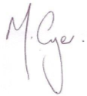
Yours sincerely,

Melvyn Cryer
Service Manager, Pet Cremation Services

Contact: 0115 901 3713
Email: petcremations@gedling.gov.uk
Website: www.gedlingpetcremations.co.uk

